1 Finance Test Date: ________________

Contents:
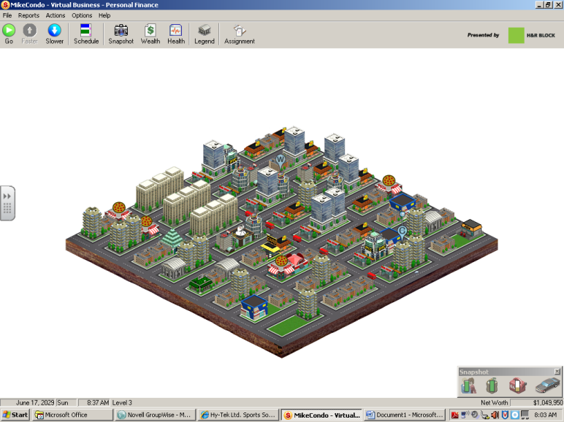
- VBPF Lesson 1 – Time Management & Health
- VBPF Lesson 2 – Finding a Job
- VBPF Lesson 3 – Eduction and Advancement
Competencies:
1: Demonstrate positive work ethic
2: Demonstrate integrity
4: Demonstrate self-representation skills
7: Demonstrate creativity and resourcefulness
9: Demonstrate effective reading and writing skills
10: Demonstrate critical thinking and problem-solving skills
12: Demonstrate an understanding of workplace organizations, systems, and climates
14: Demonstrate job-acquisition and advancement skills
15: Demonstrate time-, task-, and resource-management skills
16: Demonstrate job-specific mathematics skills
18: Demonstrate proficiency with technologies common to a specific occupation
19: Demonstrate information technology skills
20: Demonstrate an understanding of Internet use and security issues
Demonstrating Knowledge of Income Earning and Reporting
110: Examine how personal choices about education, training, skill development, and careers impact earnings.
111: Differentiate among sources of income.
112: Calculate net pay.
113: Investigate employee benefits and incentives.
Financing Education after High School
138: Identify sources of financial aid.
139: Examine types of student loans.
140: Explain the repayment process for student loans.
141: Describe types of student grants.
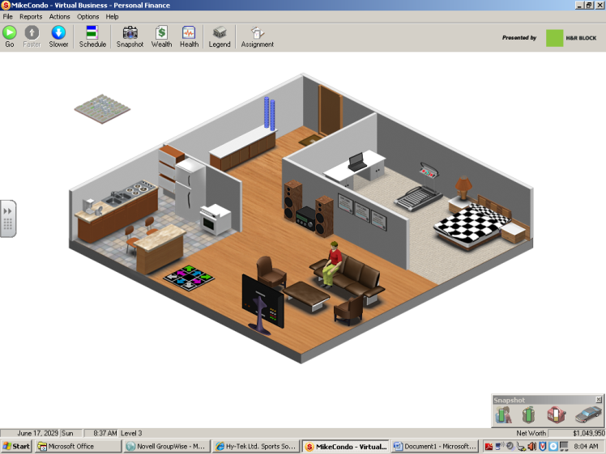
142: Describe types of scholarships.
143: Describe investment options to pay for college costs.
144: Identify ways to make the cost of postsecondary education affordable.
Developing Career Exploration and Employability Skills
149: Investigate career opportunities.
150: Identify personal interests, aptitudes, and attitudes related to the characteristics found in successful workers.
152: Research a company in preparation for a job interview.

Vocabulary:

- Time Management
- Basic Needs
- Goals
- Sedentary
- Values
- (Career)Advancement
- Career Path
- Cost of Living
- Aptitude
- Salary
- Apprenticeship
- Associate’s Degree
- Bachelor’s Degree
- Career Ladder
- Cooperative Education
- Internship

