Lesson 1
Computers and Computer Systems

Computer Literacy BASICS: A Comprehensive Guide to IC³, 3rd Edition

About the Presentations
- The presentations cover the objectives found in the opening of each lesson.
- All lesson objectives are listed in the beginning of each presentation.
- You may customize the presentations to fit your class needs.
- Some figures from the lessons are included. A complete set of images from the book can be found on the Instructor Resources disc.

Objectives
- Understand the importance of computers.
- Define computers and computer systems.
- Classify different types of computer devices.
- Use computer systems.
- Identify system components.
- Describe the role of the central processing unit.
- Define computer memory.
- Describe how data is represented.
- Identify types of storage devices.
- Care for storage media.

Vocabulary

- arithmetic/logic unit (ALU)
- binary
- bit
- BIOS ROM
- byte
- central processing unit (CPU)
- circuit board
- computer
- control unit
- data
- dual-core processor
- embedded
- computers
- file allocation table (FAT)
- hard disks
- hardware
- Information
- memory
- mobile devices
- motherboard
- multicore processor
- network drive
- notebook computers
- random access memory (RAM)
- Read-only memory (ROM)
- remote storage
- server
- software
- supercomputer
- tablet PC
- tracks
- USB flash drive

Understanding the Importance of Computers
- The is one of the most important inventions of the past century.
- A Brief of the Computer:
  - The first computers were developed in the late and early 1950s for use by the and government.
  - The first computer was built in 1976. The IBM was introduced in 1981.

Defining Computers and Computer Systems
- A computer is an electronic that follows a series of referred to as an information processing cycle.
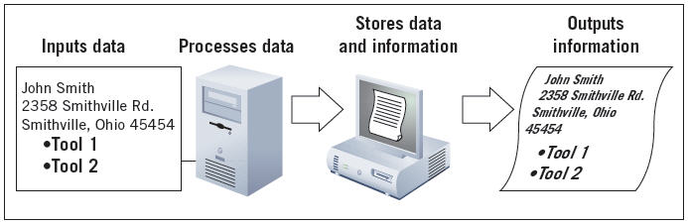
- A computer system includes , software, data, and people.

Classifying Computers
- -purpose computers are used mostly to something else.
- -purpose computers are divided into categories, based on their physical , function, , and performance:
  - Desktop and notebook computers
  - Server
  - Mobile devices
  - Tablet PC
  - Mainframe computer
  - Supercomputer
  - Embedded computers
  - Portable players

Using Computer Systems
- Computers are used for kinds of tasks.
- Computers take data and change it into information. An example of the procedure:
  - You programs and data with some type of input .
  - The computer uses to process the data and to turn it into information.
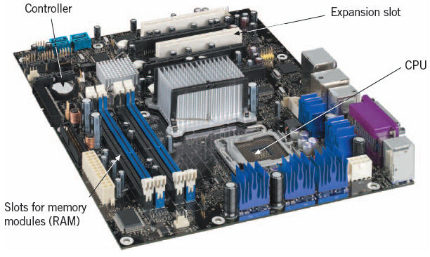
  - You the information to some type of device.
  - You it for later retrieval.

Identifying System Components
- The is a board that contains integral components—central processing unit, memory, basic controllers, and expansion slots.

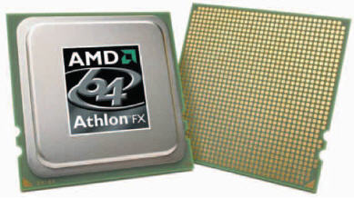
- The Central Processing Unit:
- The central processing unit (CPU) is the of the computer.
- The CPU has primary sections: the arithmetic/logic unit and the unit.

- The Arithmetic/Logic Unit:
- The arithmetic/logic unit (ALU) performs computations and operations.
- The Control Unit:
- The control unit all of the processor’s .
- You communicate with the computer through programming .
- The computer uses machine language, or , which is all 1s and 0s.
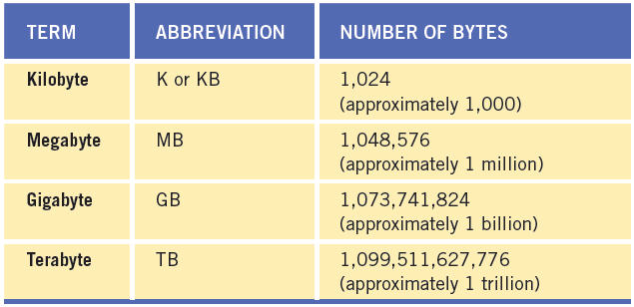
- Recognizing How a Computer Represents Data:
- In language, the control unit sends out necessary messages to the instructions. A single zero or a single one is a bit. A byte is a single character.

- Memory:
- Memory can be term or term.
- Random Access Memory:
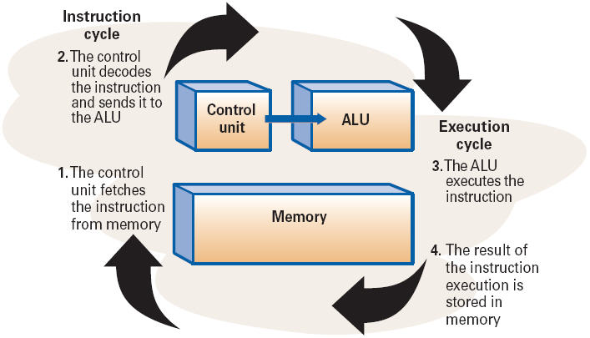
- The memory on the motherboard is term, called access memory ( ).
- Data, information, and program instructions are stored temporarily on a RAM chip and when the computer is turned off.
- The cycle is the amount of it takes to instructions to perform a specified task and complete the command.
- The cycle refers to the amount of time it takes the CPU to the instruction and store the results in RAM.
- Together, the instruction cycle and one or more execution cycles create a cycle.

- Read-Only Memory:
- Another type of memory found on the motherboard is -only memory ( ).
- ROM chips store specific instructions that are needed for computer . These instructions on the chip even when the power is turned off.
- The more common of these is the ROM, containing instructions to start the system when you turn on the computer.

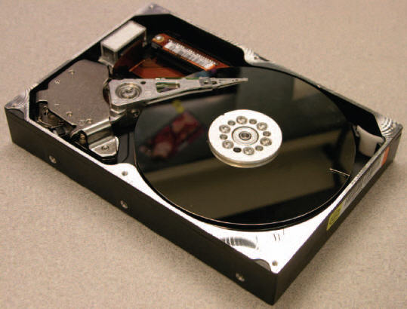

Identifying Types of Storage Devices
- To keep a copy of data, you must store it on a device.
- Magnetic Storage Devices:
- Data is stored in tracks in a special log on the disk called a file allocation table ( ).
- Hard Disk:
- Advantages: and capacity
- Magnetic tape:
- Magnetic tape primarily is used for purposes and data collection.
- 3½-Inch Disks and Zip Disks:
- Since the introduction of USB drives and -state storage media, disks are not as widely used.
- Optical Storage Devices:
- Use technology to read and data on silver platters, like CDs and DVDs.
- Solid-State Storage Media:
- Removable medium that uses integrated , such as flash drive
- Network Drives:
- Hard drive or tape connected to a network and is available to and shared by multiple users.

Caring for Storage Media
- Keep away from fields.
- Avoid temperatures.
- Remove media from drives and store them when not in use.
- When handling DVDs and other optical discs, hold them at the .
- try to remove the media from a drive when the drive indicator is on.
- Keep discs in a case when transporting.

Computers in Your Future
- One of the major areas of in the evolution of computers will be connectivity, or the ability to with other computers.
- and mobile devices will become the norm.
- Computer literacy, which is the and understanding of computers and their , will become even more important.

Summary
In this lesson, you learned:
- A computer is an electronic device that receives data, processes data, produces information, and stores the data and information.
- A computer derives its power from its speed, reliability, accuracy, storage, and communications capability.
- Computer classifications include personal computers (desktop and notebook), mobile devices, servers, mainframes, and supercomputers.
- Almost all computers perform the same general functions: input, processing, output, and storage. Input, output, and processing devices grouped together represent a computer system.
- The machine cycle is made up of the instruction cycle and the execution cycle.
- The motherboard is the center of all processing. It contains the central processing unit (CPU), memory, and basic controllers for the system. It also contains ports and expansion slots.
- The motherboard contains different types of memory. Random access memory (RAM) is volatile and is used to store instructions, data, and information temporarily. Read-only memory (ROM) is nonvolatile and is used to store permanent instructions needed for computer operations.
- The CPU is the brains of the computer. The CPU has two main sections—the arithmetic/logic unit (ALU) and the control unit. All calculations and comparisons take place in the ALU. The control unit coordinates the CPU activities.
- To maintain a permanent copy of data, you should store it on some type of storage medium. The three categories of storage media are magnetic storage, optical storage, and solid-state storage.

